|  |
| --- |
| Thickness (") |
| 0.754 |
| 0.735 |
| 0.754 |
| 0.748 |
| 0.740 |
| 0.752 |
| 0.747 |
| 0.740 |
| 0.751 |
| 0.741 |
| 0.740 |
| 0.742 |
| 0.748 |
| 0.732 |
| 0.750 |
| 0.747 |
| 0.750 |
| 0.752 |

Quiz 1 practice – Graphical Descriptive Statistics

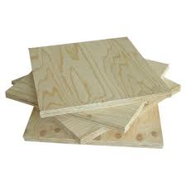 1) To test new equipment for making ¾" plywood, measurements of thickness were obtained.

a) Create a frequency table with five classes, by filling in all of the information below:

Class: range of values

Frequency: # of occurrences

Relative Frequency: occurred/total sample (1/18=0.0555556)

|  |  |  |
| --- | --- | --- |
| **Class** | **Frequency** | **Relative Frequency** |
| (.730, .735] | 1 | 0.05555556 |
| (.735, .740] | 1 | 0.05555556 |
| (.740, .745] | 5 | 0.27777778 |
| (.745, .750] | 4 | 0.22222222 |
| (.750, .755] | 7 | 0.38888889 |

b) Create a histogram by filling in the information, and labeling where appropriate:

2. The test scores of 2287 Grade 8 scores in the Netherlands are represented by the ogive below.

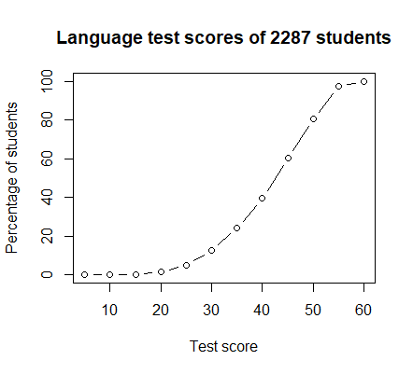

1. What proportion of students had scores below 50?
   * 1. 79%
2. What proportion of students had scores between 30 and 40?
   * 1. 15%-40%, ~25% of students
3. What range of scores represents the top 25% of the class?
   * 1. 48-60

1. The times between Old Faithful eruptions, in minutes, are given in the stem plot below.

The decimal point is 1 digit(s) to the right of the |

4 | 3

4 | 55566666777788899999

5 | 00000111111222223333333444444444

5 | 555555666677788889999999

6 | 00000022223334444

6 | 555667899

7 | 00001111123333333444444

7 | 555555556666666667777777777778888888888888889999999999

8 | 000000001111111111111222222222222333333333333334444444444

8 | 55555566666677888888999

9 | 00000012334

9 | 6

1. What is the range of the data?
   * 1. 43-96min
2. Describe the distribution of the data.
   * 1. Most common wait times between eruptions are: 75-85mins & 50-55mins apart
3. Which 10-minute range contains the largest number of waiting times between eruptions?
   * 1. 75min to 85min

Answers

1.

a)

|  |  |  |
| --- | --- | --- |
| Classes | Frequency | Rel. Freq |
| [0.730, 0.735) | 1 | 0.055556 |
| [0.735, 0.740) | 1 | 0.055556 |
| [0.740, 0.745) | 5 | 0.277778 |
| [0.745 - 0.750) | 4 | 0.222222 |
| [0.750, 0.755) | 7 | 0.388889 |

b)

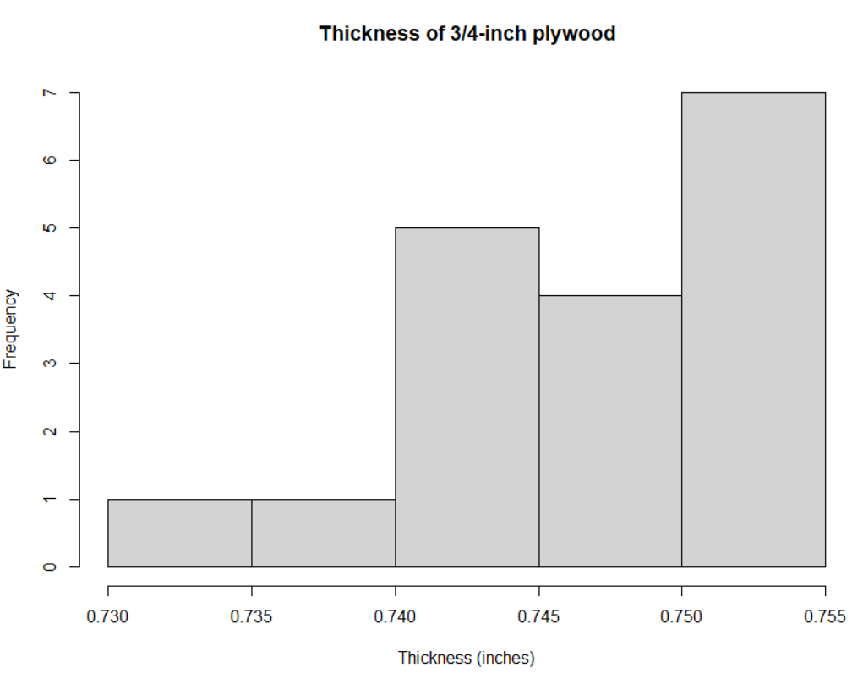

2. a) 80%

b) 25%

c) 48-60

3. a) 43-96 min

b) bimodal, with a lot of eruptions between 50 and 55 minutes apart, and a lot between 75 and 80 minutes apart

c) 75-85 min